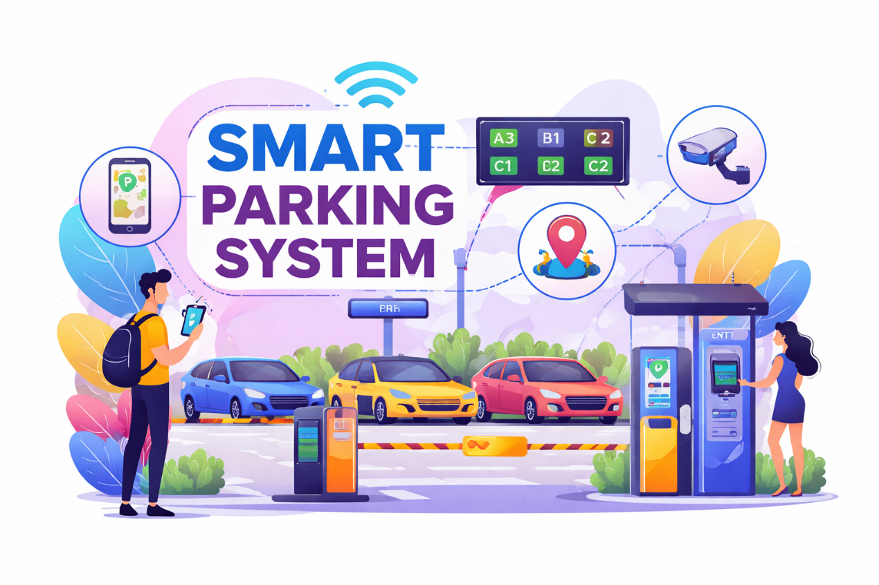

SMART PARKING System


Atpadi Education Society’s
SHRIMANT BABASAHEB DESHMUKH MAHAVIDYALAYA, ATPADI.
Tal-Atpadi, Dist-Sangli.
Accredited by NAAC with “B++” Grade (CGPA-2.94)
Department of Computer Application (BCA-III)
A Project Report
On
SMART PARKING SYSTEM
Submitted By
Mr. Shinde Shrikrushna Ramchandra
Mr. Karande Ganesh Suresh
Mr. Gaikwad Yashraje Pandurang
Under Guidence Of
Prof. MS. JADHAV M. .

Affiliated To
SHIVAJI UNIVERSITY, KOLHAPUR
Year 2025-2026


Atpadi Education Society’s
SHRIMANT BABASAHEB DESHMUKH MAHAVIDYALAYA, ATPADI.
Tal-Atpadi, Dist-Sangli.
Accredited by NAAC with “B++” Grade (CGPA-2.94)
Department of Computer Application (BCA-III)

This is to certify that Mr. Shinde Shrikrushna, Mr.Karande Ganesh , Mr.Gaikwad Yashraje the students of BCA-III (SEM-VI) has successfully completed the project in title “Smart Parking System” towards partial completion of BCA-III for SHIVAJI UNIVERSITY, KOLHAPUR in Academic Year 2025-2026.
Place :- Atpadi.
Date :-

Project Guide Examiner Head of Department
( Prof. Ms. Jadhav M. . ) ( Prof. Mr. Patil A.V. )

Atpadi Education Society’s
SHRIMANT BABASAHEB DESHMUKH MAHAVIDYALAYA, ATPADI.
Tal – Atpadi , Dist – Sangli.
Accredited by NAAC with “B++” Grade (CGPA-2.94)
Department of Computer Application (BCA-III)
DECLARATION
To,
The Principal,
S. B. D. M. Atpadi.
Respected Sir,
We undersigned hereby declare that the project report entitled, “Smart parking System” written and submitted under Guidance Prof. Mr. jadhav M. . is our original work. The empirical finding in this report are based on information collected by us.
Place: - Atpadi.
Date:-
Seat No.
- Shinde Shrikrushna Ramchandra
- Karande Ganesh Suresh
- Gaikwad Yashraje pandurang

ACKNOWLEDGEMENT
We will take this opportunity to gracefully thank to all those people, without whom this ‘Project’ would not have been succeeded. Every helping hand has their own special way to contribute the success of this project.
We would like to sincere thanks to our teachers and our college for their variable co-operation and support, without whom it was difficult to complete this project.
We are very grateful to our collage for providing us a well establishment laboratory to perform this work in collage.
We are very thankful to Mr. Prof. Mr. Jadhav M.. and Mr. Prof. Patil A. V. (HOD), for their contribution for the improvement in the project to make it more elegant.
Also, we would like to express our thanks to all staff member and those who directly and indirectly supported us to complete this project.

Place :- Atpadi.
Date :-

INDEX
No. | Title | Description | Page No.
1 | Introduction | Introduction | 11–12
 |  | Working of System | 13–16
 |  | Need and Scope of System | 17–19
2 | Proposed System | Objectives | 21
 |  | Software Requirement Specification | 22–25
3 | System Diagrams | DFD | 27–29
 |  | ERD | 30
 |  | System Requirement  (Hardware & Software) | 32–34
4 | System Design | Database Design | 36–40
 |  | Input Design | 41–45
 |  | Output Design | 46–67
5 | User Manual | User Manual | 69–74
6 | Input and Output Screens | Screens | 76–78
7 | Conclusion and Suggestion | Conclusion and Suggestion | 80–81
 |  | Future Enhancement | 82–83
8 | References | References | 85

Introduction
1.1 Introduction
The Smart Parking System is a modern web-based solution designed to overcome these problems by providing an efficient and automated way of managing parking spaces. This system allows users to check the availability of parking slots in real time and reserve them in advance using an online platform.
The project is developed using Django framework, which ensures a secure and scalable backend, along with a user-friendly interface built using web technologies like HTML, CSS, and JavaScript. It provides separate functionalities for users and administrators, making the system easy to operate and manage.
Users can view available parking areas, select slots, and book them for a specific time duration. On the other hand, administrators can monitor parking activities, manage slots, and generate reports for better decision-making.
This system not only saves time and fuel but also reduces traffic congestion and improves overall parking efficiency. The Smart Parking System is an ideal solution for places like malls, offices, colleges, and smart cities.

1.2 Working of System

1.User Registration & Login
- The user first registers on the system by providing basic details.
- After registration, the user logs in using credentials.
- Authentication ensures secure access to the system.

2.View Parking Areas & Slots
- After login, the user can view available parking areas.
- Each area shows:
  - Total slots
  - Available slots
  - Occupied / Reserved slots

3.Real-Time Slot Availability
- The system displays real-time status of each parking slot:
  - Available
  - Reserved
  - Occupied
- Data is fetched from the database and updated dynamically.

4.Slot Reservation Process
- User selects:
  - Parking area
  - Slot
  - Start time & End time
- The system checks:
  - Slot availability
  - Time conflict (no overlapping bookings allowed)
- If valid, the slot is successfully reserved.

5.Database Update
- After booking:
  - Reservation details are stored in the database
  - Slot status changes from Available → Reserved

6.Automatic Slot Management
- When reservation time ends:
  - Slot automatically becomes Available
- If user occupies slot:
  - Status changes to Occupied

7.User Dashboard
- Users can:
  - View current bookings
  - Check reservation history
  - Cancel bookings (if allowed)

8.Admin Control Panel
- Admin can:
  - Add parking areas
  - Manage slots
  - Block/unblock slots
  - Monitor all reservations
  - View reports and analytics

1.3 Need and Scope of System
Need of the System

1.To Reduce Traffic Congestion
Vehicles often circle around parking areas searching for space, which increases traffic.
This system provides real-time slot availability, reducing unnecessary movement.

2.To Save Time and Fuel
Manual searching for parking wastes both time and fuel.
With this system, users can book slots in advance, saving resources.

3.To Improve Parking Efficiency
Traditional systems do not use parking spaces efficiently.
The system ensures optimal utilization of available slots.

4.To Provide Real-Time Information
Users need accurate and updated information.
This system provides live updates of parking slot status.

5.To Reduce Human Effort
Manual parking management requires staff and supervision.
The system automates the process, reducing human involvement and errors.

6.To Ensure Better Management
Parking authorities need proper monitoring tools.
The system provides an admin dashboard for control and reporting.

7.To Enhance User Convenience
Users get a simple and user-friendly interface to:
- Check availability
- Reserve slots
- Manage bookings

8.To Support Smart City Development
Smart parking is an important part of smart city infrastructure, helping in better urban planning.

.

Proposed System

2.1 Objectives
The main objectives of the system are:

1.To Provide Real-Time Parking Information
To display live availability of parking slots, helping users quickly find free spaces.

2.To Enable Online Slot Reservation
To allow users to book parking slots in advance, reducing the need for manual searching.

3.To Reduce Traffic Congestion
To minimize unnecessary vehicle movement by guiding users directly to available parking slots.

4.To Save Time and Fuel
To eliminate time wasted in searching for parking, thereby saving fuel and effort.

2.2 Software Requirement Specification
1. Functional Requirements

1. Login and Authentication System
• The system provides secure login for users and admin.
• Only valid username and password allow access.
• Unauthorized users are restricted from accessing the system.
• Logout option is available for security.

2. Manage Parking Areas
• Admin can add parking area details (name, location, total slots).
• Existing parking areas can be updated or deleted.
• System validates inputs before saving data.

3. Manage Parking Slots
• Admin can create multiple slots under a parking area.
• Each slot has a slot number and status (Available / Reserved / Occupied).
• Slots can be updated or blocked/unblocked by admin.

4. View Slot Availability
• Users can view available parking slots in real time.
• System displays slot status clearly.
• Data is updated dynamically from the database.

5. Parking Slot Reservation
• Users can book parking slots by selecting date and time.
• System checks slot availability before booking.
• Overlapping bookings are prevented.
• Reservation details are stored in the system.

6. Reservation Management
• Users can view their booking history.
• Admin can monitor all reservations.
• Reservations can be updated or cancelled if required.

7. Automatic Slot Status Update
• Slot status changes automatically based on reservation time.
• After booking time ends, slot becomes available again.
• System ensures real-time updates.

2. Non-Functional Requirements
Non-functional requirements define system performance and quality.

1. Performance Requirements
• The system should respond quickly to user requests.
• Real-time slot availability must be updated without delay.
• The system should handle multiple users simultaneously.

2. Security Requirements
• The system must provide secure login authentication.
• User data should be protected from unauthorized access.
• Role-based access control should be implemented (User/Admin).
• CSRF protection should be enabled.

3. Usability Requirements
• The system should have a simple and user-friendly interface.
• Users should easily navigate between pages.
• Proper instructions and messages should be displayed.

4. Reliability Requirements
• The system should work without failures during operation.
• Data should be stored accurately without loss.
• Backup mechanisms should be available.

5. Scalability Requirements
• The system should support an increasing number of users.
• It should handle multiple parking areas and slots efficiently.

6. Availability Requirements
• The system should be available 24/7.
• Downtime should be minimal.

7. Maintainability Requirements
• The system should be easy to update and maintain.
• Code should be modular and well-structured.

8. Compatibility Requirements
• The system should work on different browsers (Chrome, Firefox, Edge).
• It should be accessible on mobile, tablet, and desktop devices.

9. Data Integrity Requirements
• The system must ensure accurate and consistent data.
• Invalid or duplicate data entries should be prevented.

10. Response Time Requirements
• Pages should load within a few seconds.
• Booking process should be completed quickly.

System Diagrams

3.1 Data Flow Diagram (DFD)
Level 0 (Context Diagram):
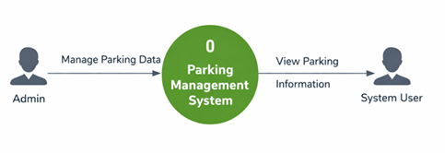
Fig. - DFD Level 0
The Level 0 DFD represents the overall system as a single process and shows interaction between the external entity and the system.

Level 1 DFD:
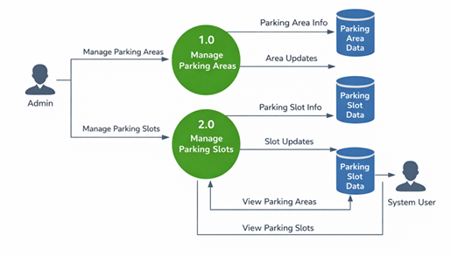
Fig. - DFD Level 1

Level 1 DFD shows the internal working of the Parking Management System by breaking it into main processes like managing parking areas, slots, and user interactions.
It explains how data flows between these processes, the database, Admin, and User in more detail than Level 0.
3.2 Entity Relationship Diagram (ERD)
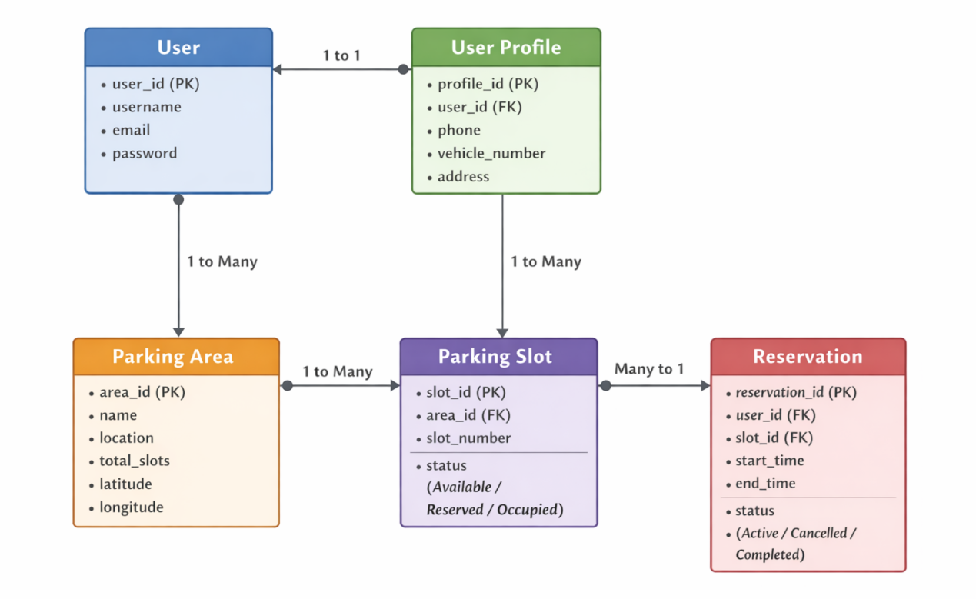
Fig- ERD
The Smart Parking System ERD shows how users, parking areas, slots, and reservations are connected.
A user can book parking slots, each slot belongs to a parking area, and reservations store booking details with time and cost.

3.3 System Requirement
Hardware Requirements
- Processor: Intel Core i3 or higher
- RAM: Minimum 4GB (8GB recommended)
- Storage: Minimum 20GB free space
Software Requirements
- Operating System: Windows / Linux / MacOS
- Frontend: HTML, CSS, Bootstrap, JavaScript
- Backend: Python with Django Framework
- Database: SQLite or PostgreSQL
- Tools: VS Code, GitHub
- Browser: Google Chrome / Edge

System Design

4.1 Database Design
The system uses a relational database with multiple tables. Each table stores specific data and is connected using primary and foreign keys.
1. User Table (Django Default)
Field Name | Data Type | Description
id (PK) | Integer | Unique user ID
username | Varchar | Username
email | Varchar | Email
password | Varchar | Password

2. UserProfile Table
Field Name | Data Type | Description
id (PK) | Integer | Profile ID
user_id (FK) | Integer | Reference to User
phone | Varchar(15) | Contact number
vehicle_number | Varchar(20) | Vehicle number
address | Text | User address

3. ParkingArea Table
Field Name | Data Type | Description
id (PK) | Integer | Area ID
name | Varchar(100) | Parking area name
location | Varchar(200) | Address/location
total_slots | Integer | Total parking slots
latitude | Float | Map latitude
longitude | Float | Map longitude

4. ParkingSlot Table
Field Name | Data Type | Description
id (PK) | Integer | Slot ID
area_id (FK) | Integer | Reference to ParkingArea
slot_number | Varchar(10) | Slot number
status | Varchar(20) | Available / Reserved / Occupied

5. Reservation Table
Field Name | Data Type | Description
id (PK) | Integer | Reservation ID
user_id (FK) | Integer | Reference to User
slot_id (FK) | Integer | Reference to ParkingSlot
start_time | DateTime | Start time
end_time | DateTime | End time
status | Varchar(20) | Active / Cancelled / Completed
total_amount | Integer | Parking cost

Key Features
- Primary keys ensure uniqueness
- Foreign keys maintain relationships
- Automatic receipt number generation
- Data integrity maintained using Django ORM

4.2 Input Design
Input Design focuses on how data is entered into the system in a correct and user-friendly way.

1. User Input
- User Registration Form
  - Username
  - Email
  - Password
- Login Form
  - Username
  - Password
- Slot Booking Form
  - Parking Area
  - Slot Selection
  - Start Time
  - End Time

2. Admin Input
- Parking Area Form
  - Area Name
  - Location
  - Total Slots
- Parking Slot Form
  - Slot Number
  - Slot Status

Input Validation
- Required fields cannot be empty
- Email must be in correct format
- Password must be secure
- Slot booking time must be valid
- Prevent duplicate or invalid entries

Input Design Principles
- Simple and user-friendly forms
- Clear labels and instructions
- Error messages for invalid input
- Dropdowns and selection options to avoid mistakes
4.3 Output Design
Output Design focuses on how processed data is displayed to the user in a clear and organized way.

1. User Outputs
- Available Parking Slots Display
  - Shows real-time status of slots (Available / Reserved / Occupied)
- Booking Confirmation
  - Displays booking details such as slot number, date, and time
- Reservation History
  - Shows previous bookings with status
- Notifications
  - Booking confirmation
  - Slot expiry alerts

2. Admin Outputs
- Parking Area Details
  - List of all parking areas with total slots
- Slot Status Report
  - Displays availability and occupancy of slots
- Reservation Reports
  - Details of all bookings by users
- Analytics Dashboard
  - Summary of parking usage and statistics

Output Design Principles
- Information should be clear and easy to understand
- Use of tables, charts, and dashboards
- Proper formatting and alignment
- Real-time updates for accuracy
- Minimal and meaningful information display

Output Formats
- On-screen display (web pages/dashboard)
- Reports (tables and summaries)
- Notifications (alerts/messages)

User Manual

Steps to Use System

User Manual

1. User Registration
- Open the Smart Parking System website
- Click on Register
- Enter details like username, email, and password
- Submit the form to create an account

2. User Login
- Click on Login
- Enter username and password
- Access the user dashboard

3. View Parking Slots
- Select a parking area
- View available, reserved, and occupied slots
- Check real-time availability

4. Book Parking Slot
- Choose an available slot
- Select start time and end time
- Click on Book Now
- Booking confirmation will be displayed

5. View Booking Details
- Go to My Bookings
- View current and past reservations
- Check booking status

6. Logout
- Click on Logout
- Safely exit the system

Admin Manual

1. Admin Login
- Login using admin credentials

2. Manage Parking Areas
- Add new parking areas
- Update or delete existing areas

3. Manage Parking Slots
- Add slots under areas
- Update slot status
- Block/unblock slots

4. Monitor Reservations
- View all user bookings
- Track slot usage

5. Generate Reports
- View parking statistics
- Analyse system usage

Input and Output Screens

1. User Register
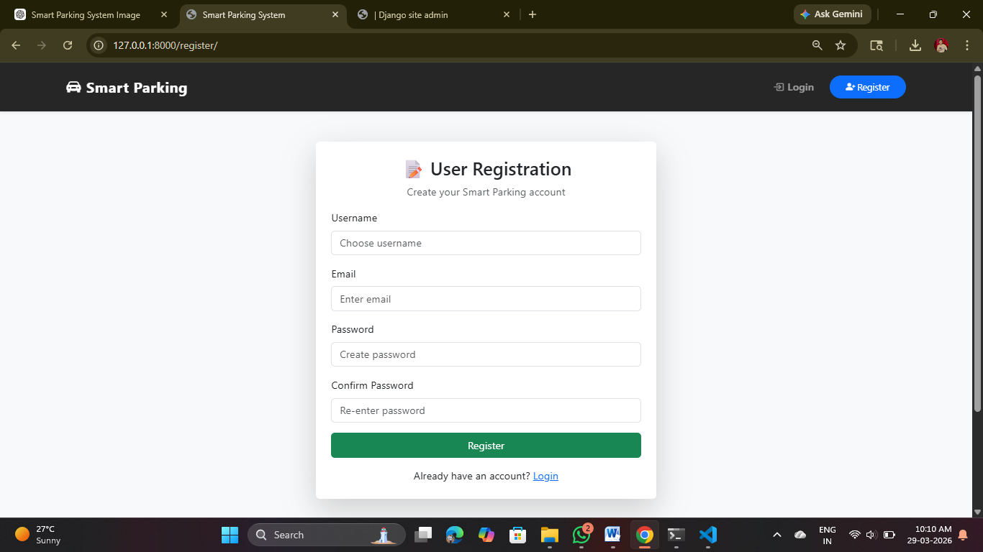

2. User Login
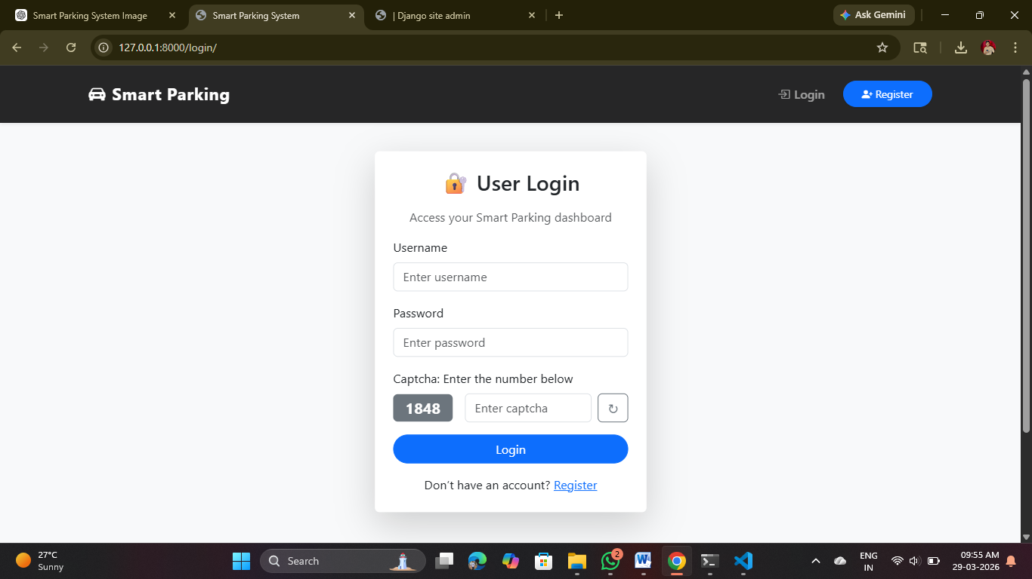

3. Home
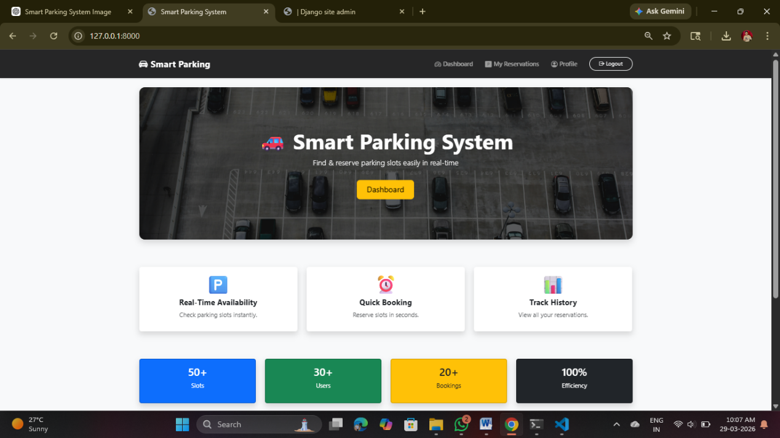

4. Dashboard
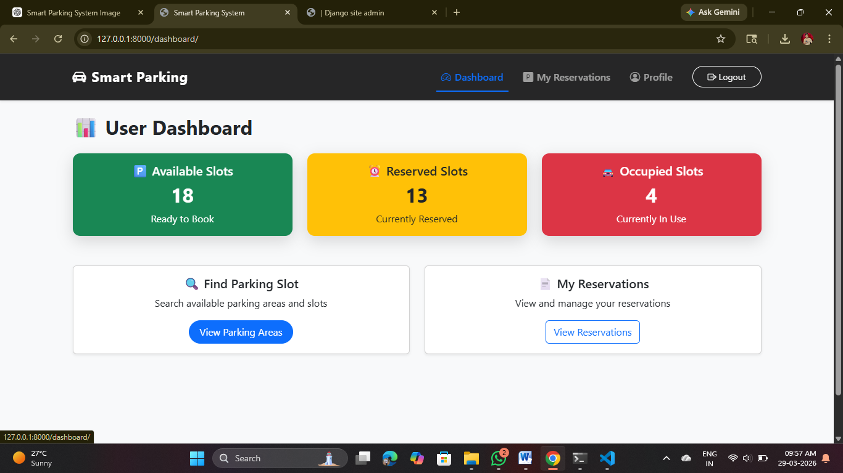

5. My Reservation
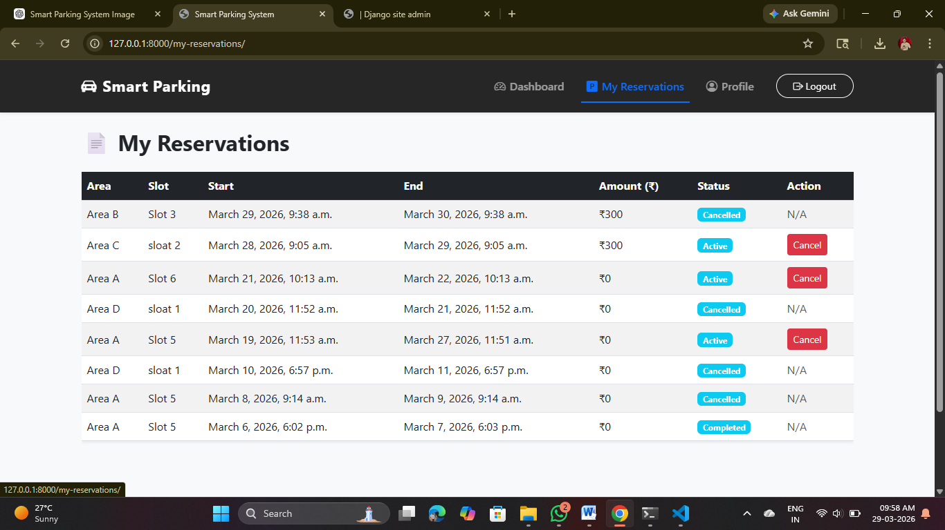

6. My profile
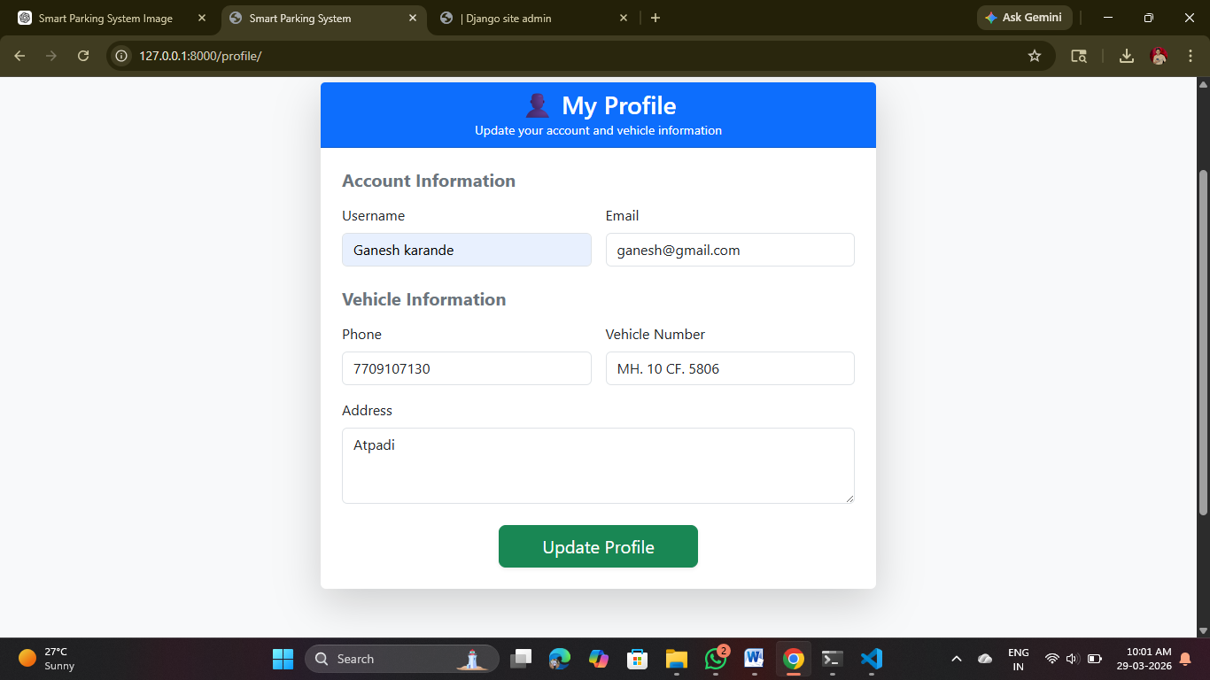

7. Parking Areas
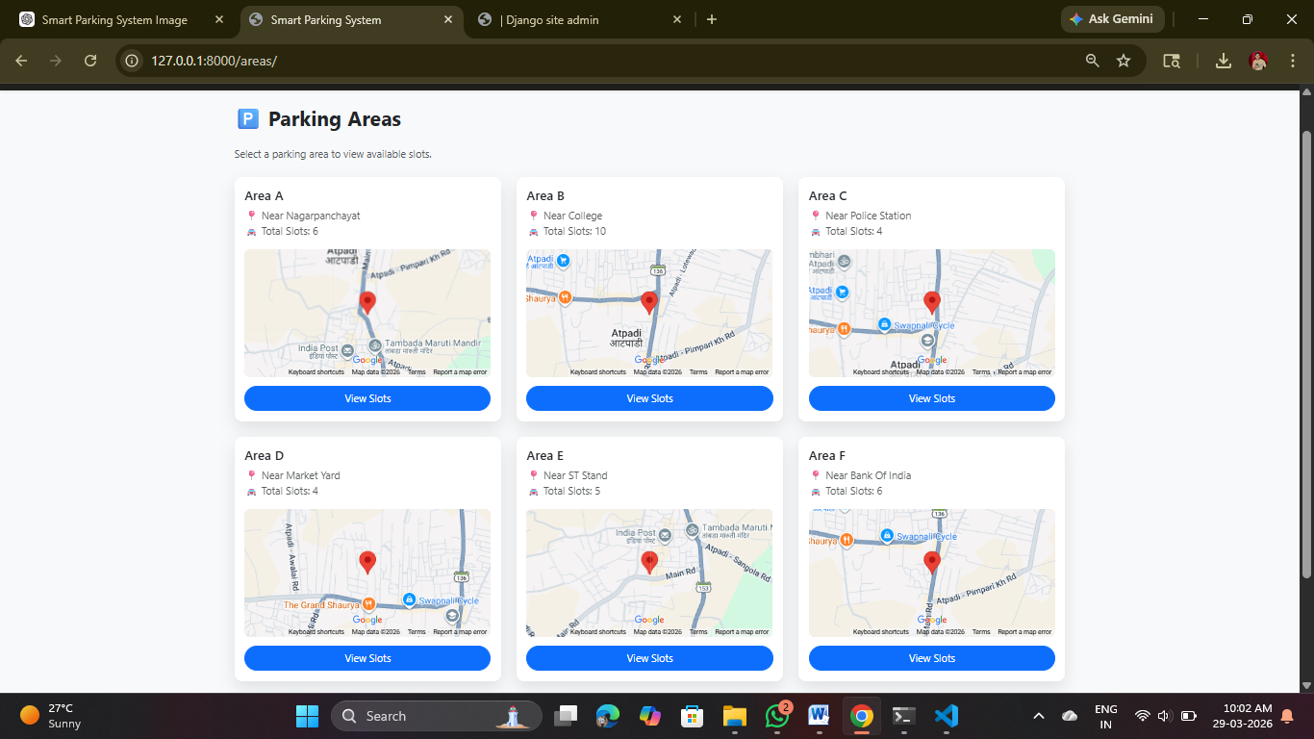

8. Parking Slots
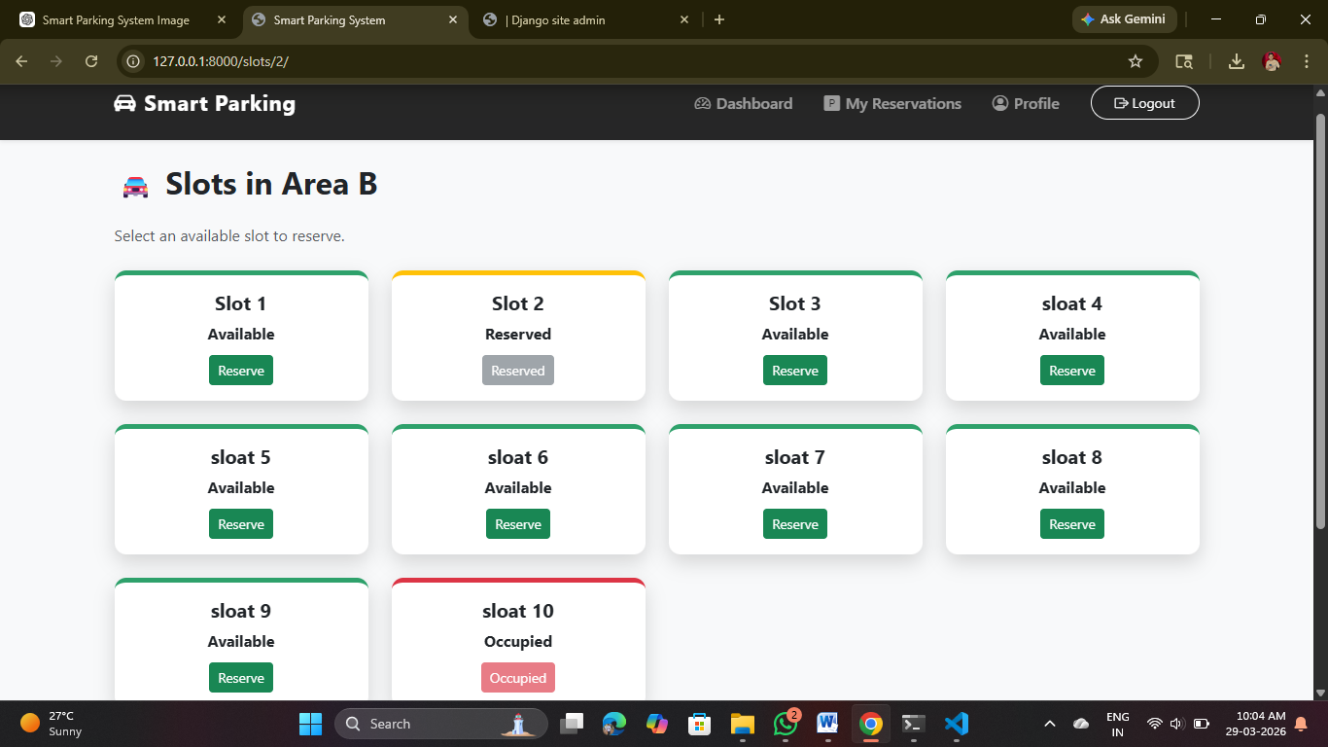

9. Reserve Slot
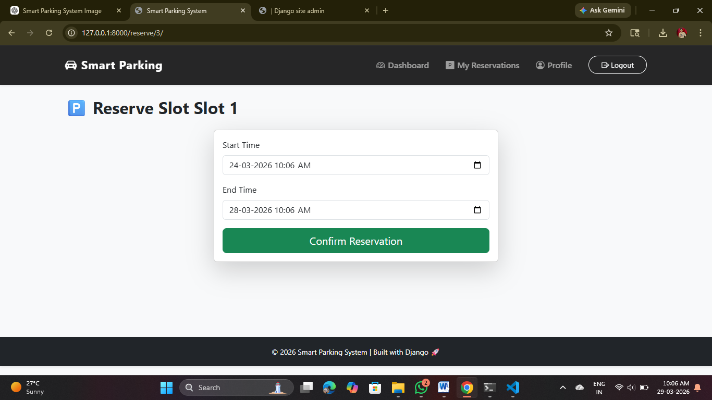

Reports :

1. Report Screen
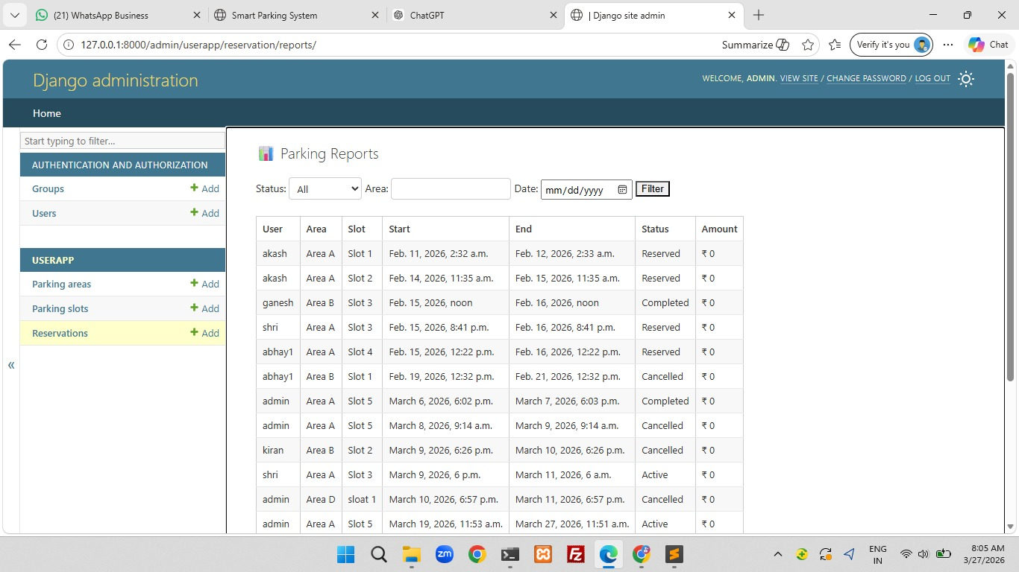

2. Active Parking:

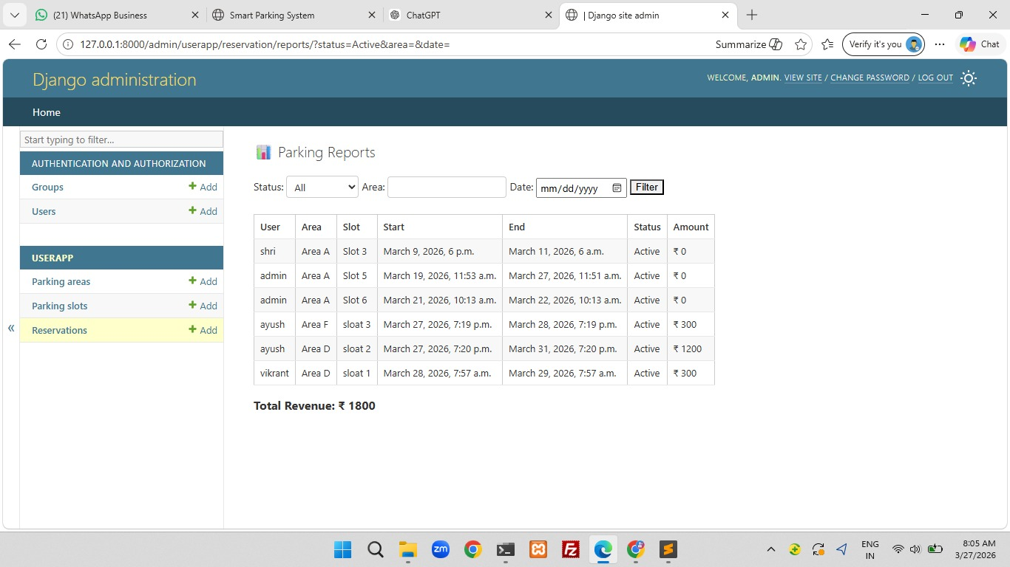

3. Parking Completed

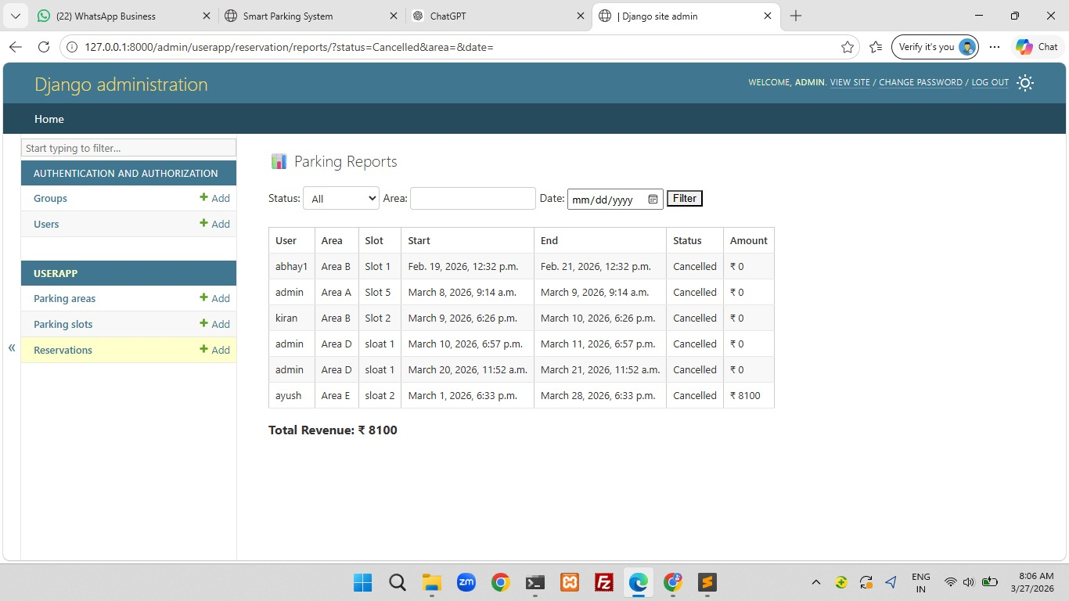

4. Parking Cancelled

5. Area wise Report

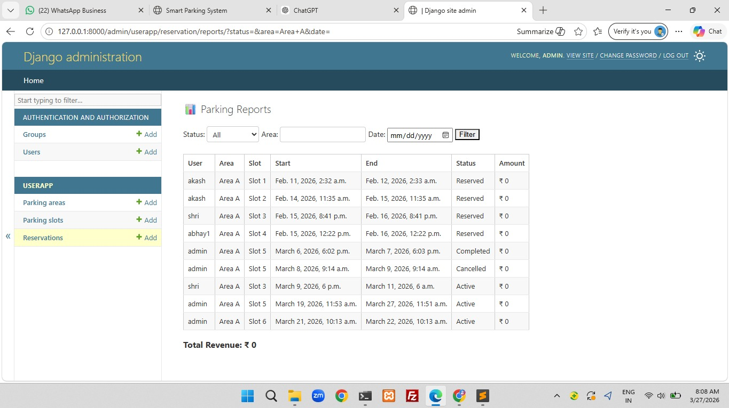

Conclusion and Suggestion

7.1 Conclusion
The Smart Parking System is an efficient and user-friendly web-based solution developed to overcome the problems of traditional parking systems. It provides real-time information about parking slot availability and allows users to reserve slots easily, reducing time and effort.
The system helps in minimizing traffic congestion, improving parking space utilization, and ensuring better management through automation. With features like online booking, slot management, and admin monitoring, the system proves to be reliable and effective for modern parking needs.
Overall, this project demonstrates the practical implementation of web technologies and database management, making it a suitable and valuable solution for real-world applications such as malls, colleges, offices, and smart cities.

7.2 Future Enhancement
Although the system is functional and efficient, it can be further improved by adding the following features:
- Integration of online payment gateway for paid parking services
- Development of a mobile application for easy access on smartphones
- Implementation of GPS navigation to guide users to the nearest available parking slot
- Use of QR code system for quick entry and exit of vehicles
- Addition of real-time sensors (IoT) to automatically detect slot availability
- Implementation of AI-based prediction system to suggest parking availability based on past data
- Integration of email and SMS notifications for booking confirmation and alerts
- Enhancement of user interface (UI/UX) for better user experience
- Support for multi-location and smart city integration
- Adding vehicle number recognition (ANPR system) for automated access control

References

References
- Django Documentation – https://docs.djangoproject.com/
- Bootstrap Documentation – https://getbootstrap.com/
- Python Documentation – https://docs.python.org/
- W3Schools – https://www.w3schools.com/
- GitHub – https://github.com/

